**DICT REGION V – CAMARINES NORTE INTERNSHIP EXPERIENCE:  
 A COMPREHENSIVE STUDENT INTERNSHIP REPORT**

A Written Report Presented to the Faculty of the

College of Computing and Multimedia Studies

Camarines Norte State College

Daet, Camarines Norte

In Partial Fulfillment of the Requirements

for the Degree in Bachelor of Science

in Information Technology

by

**MORTIGA, RENZE MEINARD**

DICT Region V - Camarines

Digital Media and ICT Training Assistant

April 2025

### TABLE OF CONTENTS

**PAGE**

CHAPTER

1 OFFICE PROFILE .................................. 3

2 REPORTS COMPILATION AND DOCUMENTATION ........... 7

Daily Attendance and Accomplishment ............. 7

Monthly Report .................................. 37

Documentation ................................... 47

3 STUDENT REFLECTION AND ANALYSIS ................. 56

Acquired Technical Competencies ................. 56

Professional Interactions and Interpersonal

Experiences ..................................... #

Significant Events .............................. #

Alignment Assessment of the BSIT Curriculum

with Industry Demands ........................... #

Proposed Recommendations for the Improvement

of the Practicum Program ........................ #

Advisory Remarks for Future Practicum and

Internship Participants ......................... #

# CHAPTER I OFFICE PROFILE

This chapter presents the profile of the office where the internship was conducted. It provides a general background of the DICT as a national agency, the roles and responsibilities of the office staff and supervisors, and the various programs and initiatives in which the interns were involved.

## **DICT Region V - Camarines Norte**

The Department of Information and Communications Technology (DICT) serves as the primary policy, planning, coordinating, implementing, and administrative entity of the Philippine government in the promotion and development of the country’s information and communications technology agenda. Established to advance national development through digital transformation, the DICT is committed to ensuring national access to quality, affordable, reliable, and secure ICT services for all. Its core functions include the formulation of national ICT policies, management of government ICT infrastructure and services, and promotion of digital literacy and cybersecurity initiatives.

The DICT Region V – Camarines Norte Provincial Office operates under the umbrella of the regional DICT offices, specifically catering to the province of Camarines Norte. This office functions as the local extension of the department’s national mandate, implementing programs and projects aligned with DICT’s overall strategic goals but tailored to the unique needs of communities within the province.

## **The DICT Camarines Norte Personnel**

Throughout the internship, the supervision and guidance of the assigned personnel at DICT Region V – Camarines Norte played a pivotal role in shaping the interns' professional experience.

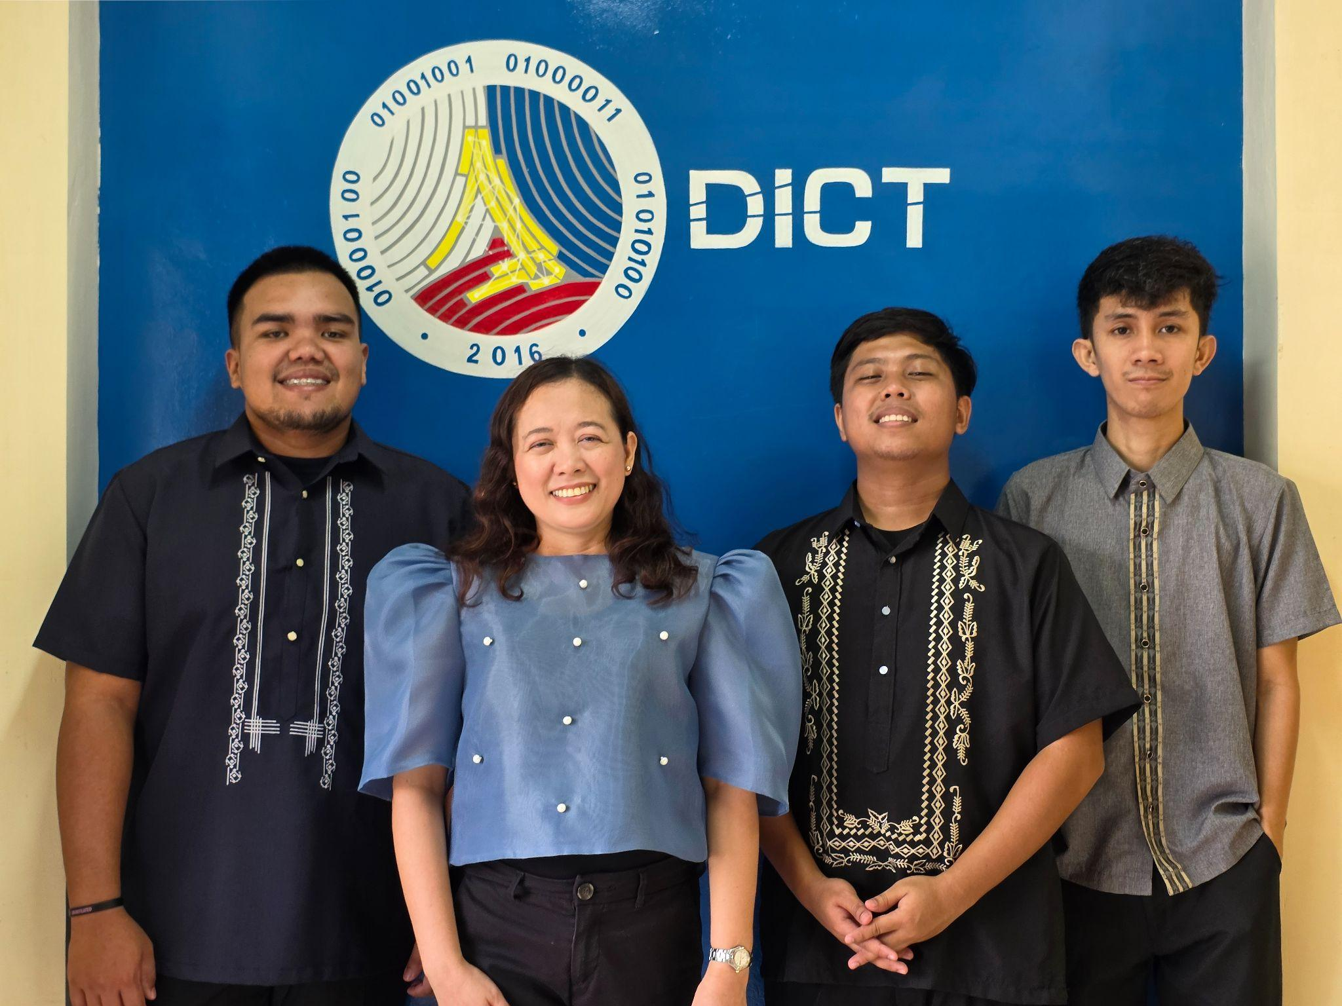**Figure 1.** DICT Region V - Camarines Norte Personnel

The provincial office is headed by Dr. Aileen L. Rillon, the DICT Provincial Officer, who served as the direct supervisor from the initial interview to the completion of the internship. Dr. Rillon was instrumental in assigning tasks and ensuring that interns were actively involved in the various functions of the office. She provided substantial responsibilities that contributed to both individual learning and institutional goals. These tasks included assisting in the preparation of publication and presentation materials, public speaking engagements, documentation efforts, and event facilitation. Her active involvement ensured that the interns were exposed to multifaceted roles that are integral to the operations of the department.

The office is also composed of dedicated personnel who contributed significantly to the interns’ daily engagements. Mr. John Vincent Macha, Project Development Officer I (PDO I) under the eGovernment Sectoral Development (eGovSD), is the lead officer responsible for the eGovPH mobile application initiatives within the province. He frequently requested the participation of interns in documentation and facilitation duties during orientations, promotional booths, and events related to the eGovPH program.

Mr. Gregorio Alan O. Bacordo, Engineer I, oversees the Free Wi-Fi for All (FW4A) project and assigns tasks focused on publications and awareness campaigns about the availability and benefits of free Wi-Fi services in Camarines Norte. Interns were tasked to support these initiatives through creative and informative content.

Additionally, Mr. John Dominique Sabila, Planning Assistant I (PLA I) for the Philippine National Public Key Infrastructure (PNPKI), delegated responsibilities relating to the development and dissemination of announcements and publication materials for the PNPKI services. He also played a leading role in representing the office during public speaking engagements conducted outside the premises, often accompanied and assisted by the interns.

# CHAPTER II REPORTS COMPILATION AND DOCUMENTATION

This chapter presents the compiled reports and documentation of the internship activities conducted at the DICT Region V – Camarines Norte. It includes a comprehensive collection of daily attendance records, monthly accomplishment reports, and documentation of the various tasks, events, and training participated in by the intern. These materials serve as verifiable records of the intern’s involvement and contributions, reflecting the range of responsibilities undertaken throughout the internship period.

## **Daily Attendance and Accomplishment**

The following images serve as a detailed log of the intern, Renze Meinard Mortiga’s, daily participation during the course of his internship. This record includes the time-in and time-out entries for each day, organized by week, spanning a total of 14 weeks. For each week, the total number of hours rendered is calculated and documented to ensure transparency and accountability in tracking the intern's working hours.

The attendance record formally commenced on January 20, 2025, and concluded on April 25, 2025, covering the entire duration of the internship program.

## 

### Figure 2. Week 1 (January 20–24) Daily Attendance and Accomplishment Report – Page 1 of 2

## 

### Figure 3. Week 1 (January 20–24) Daily Attendance and Accomplishment Report – Page 2 of 2

## 

### Figure 4. Week 2 (January 27–31) Daily Attendance and Accomplishment Report – Page 1 of 2

## 

### Figure 5. Week 2 (January 27–31) Daily Attendance and Accomplishment Report – Page 2 of 2

## 

### Figure 6. Week 3 (February 3-7, 2025) Daily Attendance and Accomplishment Report – Page 1 of 2

## 

### Figure 7. Week 3 (February 3-7, 2025) Daily Attendance and Accomplishment Report – Page 2 of 2

## 

### Figure 8. Week 4 (February 10-14) Daily Attendance and Accomplishment Report – Page 1 of 2

## 

### Figure 9. Week 4 (February 10-14) Daily Attendance and Accomplishment Report – Page 2 of 2

## 

### Figure 10. Week 5 (February 17–21) Daily Attendance and Accomplishment Report – Page 1 of 2

## 

### Figure 11. Week 5 (February 17–21) Daily Attendance and Accomplishment Report – Page 2 of 2

## 

### Figure 12. Week 6 (February 24–28) Daily Attendance and Accomplishment Report – Page 1 of 2

## 

### Figure 13. Week 6 (February 24–28) Daily Attendance and Accomplishment Report – Page 2 of 2

## 

### Figure 14. Week 7 (March 3-7, 2025) Daily Attendance and Accomplishment Report – Page 1 of 3

## 

### Figure 15. Week 7 (March 3-7, 2025) Daily Attendance and Accomplishment Report – Page 2 of 3

## 

### Figure 16. Week 8 (March 10-14, 2025) Daily Attendance and Accomplishment Report – Page 1 of 2

## 

### Figure 17. Week 8 (March 10-14, 2025) Daily Attendance and Accomplishment Report – Page 2 of 2

## 

### Figure 18. Week 9 (March 17-21, 2025) Daily Attendance and Accomplishment Report – Page 1 of 3

## 

### Figure 18. Week 9 (March 17-21, 2025) Daily Attendance and Accomplishment Report – Page 2 of 3

## 

### Figure 19. Week 9 (March 17-21, 2025) Daily Attendance and Accomplishment Report – Page 2 of 3

## 

### Figure 20. Week 10 (March 24-28, 2025) Daily Attendance and Accomplishment Report – Page 1 of 2

## 

### Figure 21. Week 10 (March 24-28, 2025) Daily Attendance and Accomplishment Report – Page 2 of 2

## 

### Figure 22. Week 11 (March 31 - April 4, 2025) Daily Attendance and Accomplishment Report – Page 1 of 2

## 

### Figure 23. Week 11 (March 31 - April 4, 2025) Daily Attendance and Accomplishment Report – Page 2 of 2

## 

### Figure 24. Week 12 (April 7-11, 2025) Daily Attendance and Accomplishment Report – Page 1 of 2

## 

### Figure 25. Week 12 (April 7-11, 2025) Daily Attendance and Accomplishment Report – Page 2 of 2

## 

### Figure 26. Week 13 (April 14-16, 2025) Daily Attendance and Accomplishment Report – Page 1 of 2

## 

### Figure 27. Week 13 (April 14-16, 2025) Daily Attendance and Accomplishment Report – Page 2 of 2

## 

### Figure 28. Week 14 (April 21-25, 2025) Daily Attendance and Accomplishment Report – Page 1 of 2

## 

### Figure 29. Week 14 (April 21-25, 2025) Daily Attendance and Accomplishment Report – Page 2 of 2

## **Monthly Report**

Monthly reports provide a structured summary of all activities and responsibilities undertaken by the intern throughout the duration of the internship program, covering the period from January to April 2025. Each monthly report is carefully organized to present the duties performed, the training or events attended, and the progress made toward key tasks and goals.

The reports also outline a comparison between the proposed activities at the start of the month and the actual accomplishments achieved, allowing both the intern and the supervisor to monitor productivity and effectiveness.

A notable feature of the monthly reports is the inclusion of a personal reflection where the intern discusses challenges encountered and describes the strategies used to overcome those challenges.

To validate the accuracy of each report, every entry is reviewed and signed by the assigned supervisor, confirming the legitimacy of all accomplishments and experiences written. These reports serve not only as a formal documentation of the intern's contributions but also as a valuable tool for self-assessment and continuous improvement.

## 

### Figure 30. January Monthly Report – Page 1 of 2

## 

### Figure 31. January Monthly Report – Page 2 of 2

## 

### Figure 32. February Monthly Report – Page 1 of 3

## 

### Figure 33. February Monthly Report – Page 2 of 3

## 

### Figure 34. February Monthly Report – Page 3 of 3

### 

## 

### Figure 35. March Monthly Report – Page 1 of 2

## 

### Figure 36. March Monthly Report – Page 2 of 2

## 

### Figure 37. April Monthly Report – Page 1 of 2

## 

### Figure 38. April Monthly Report – Page 2 of 2

## **Documentation**

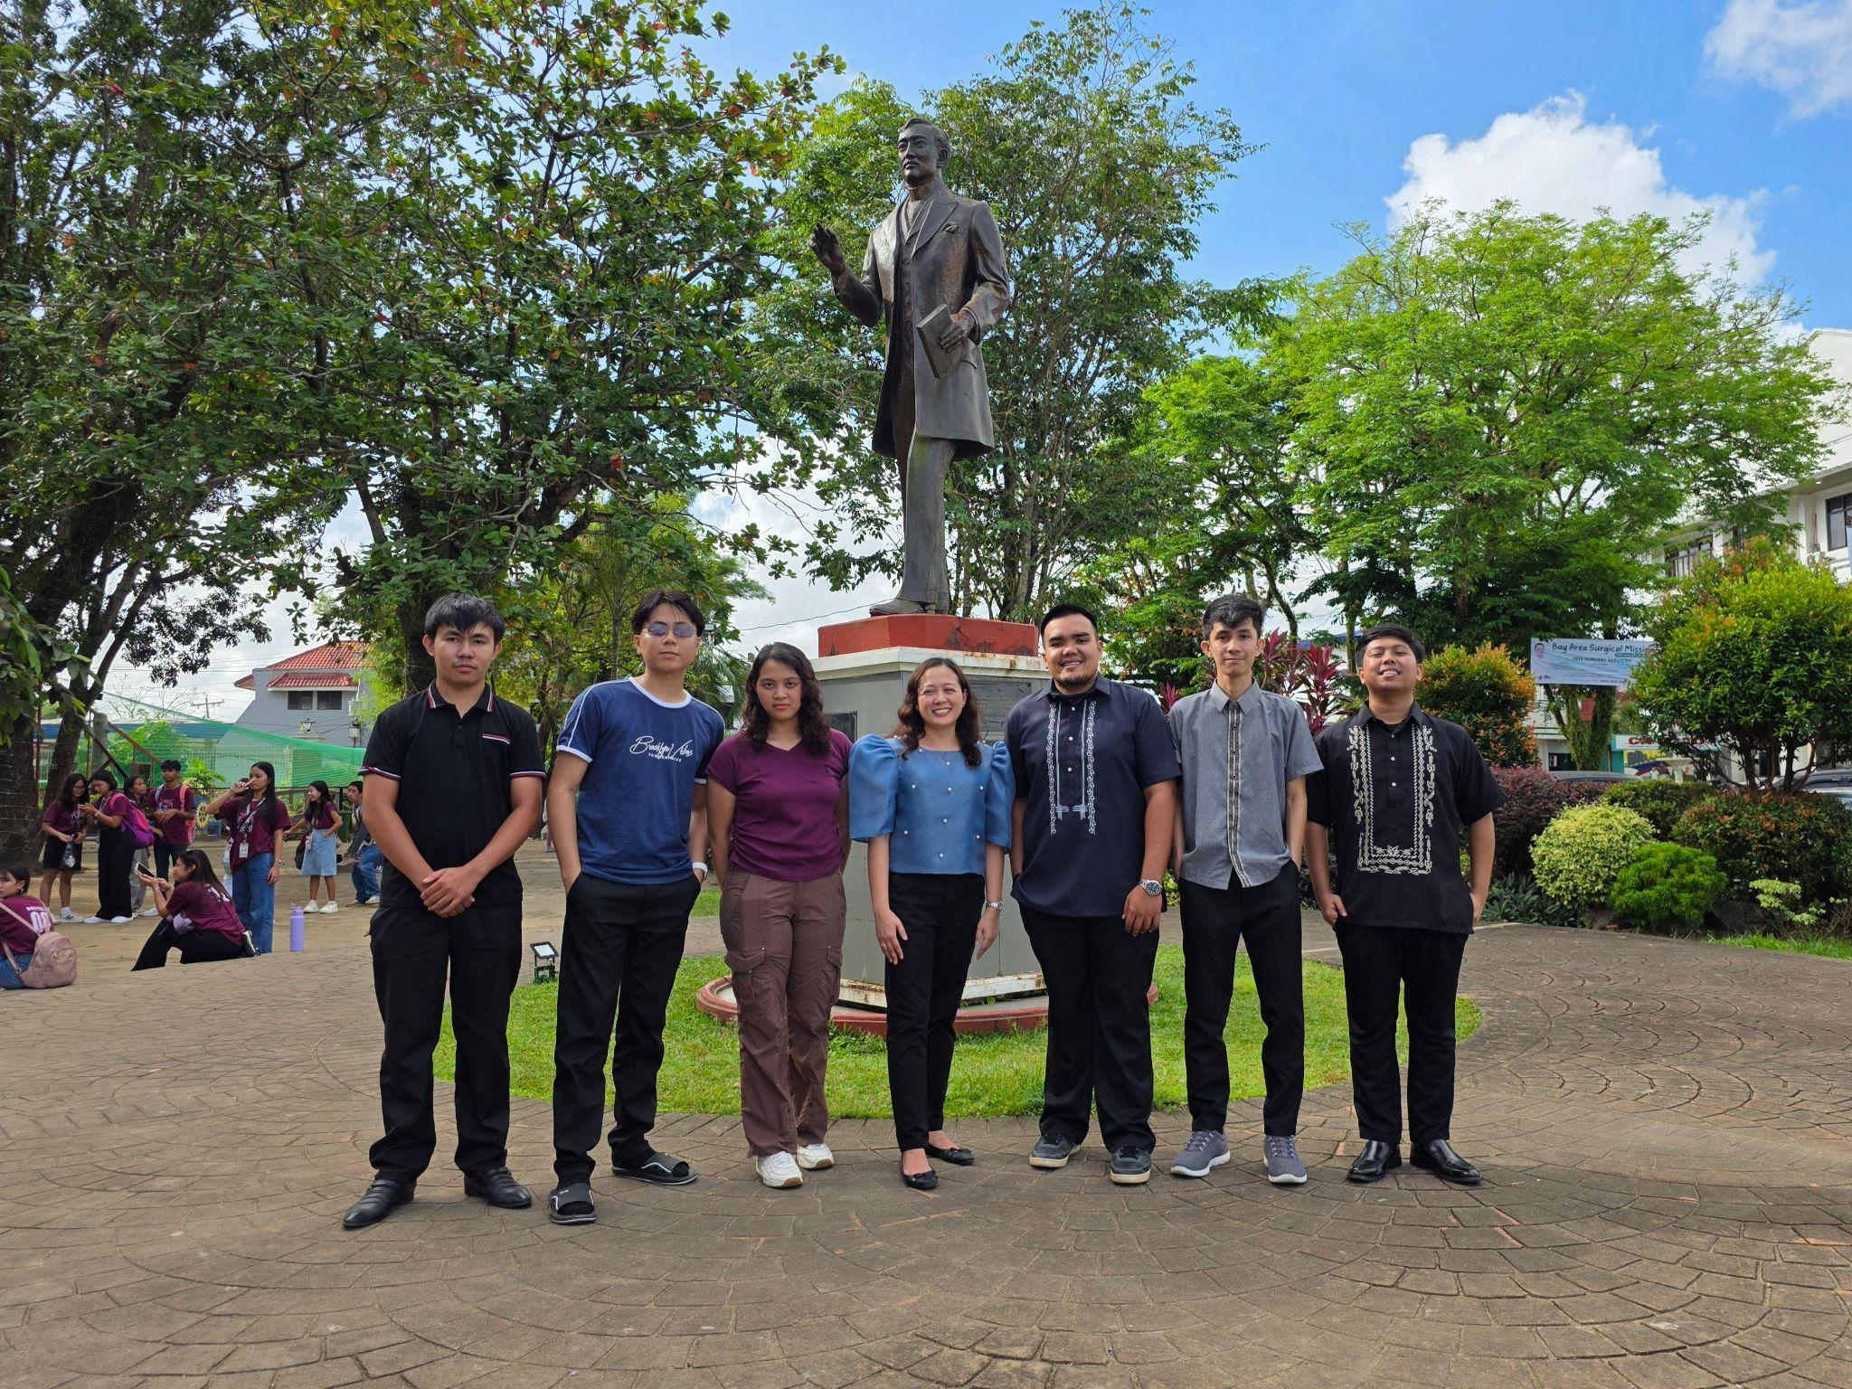

### Figure 39. DICT Region V - Camarines Norte Officers

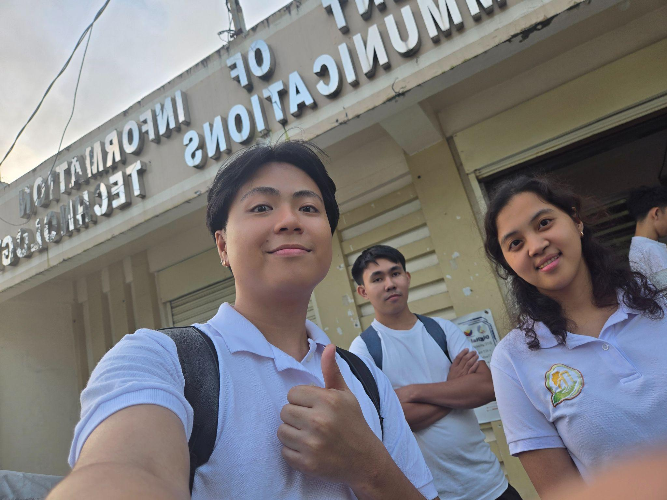

### Figure 40. Interns Day 1 Group Photo

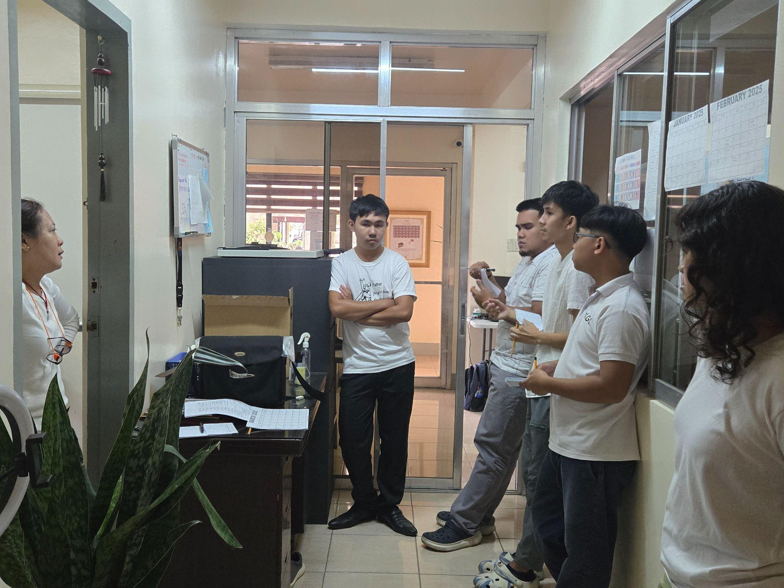

### Figure 41. Weekly Meeting and Task Designation

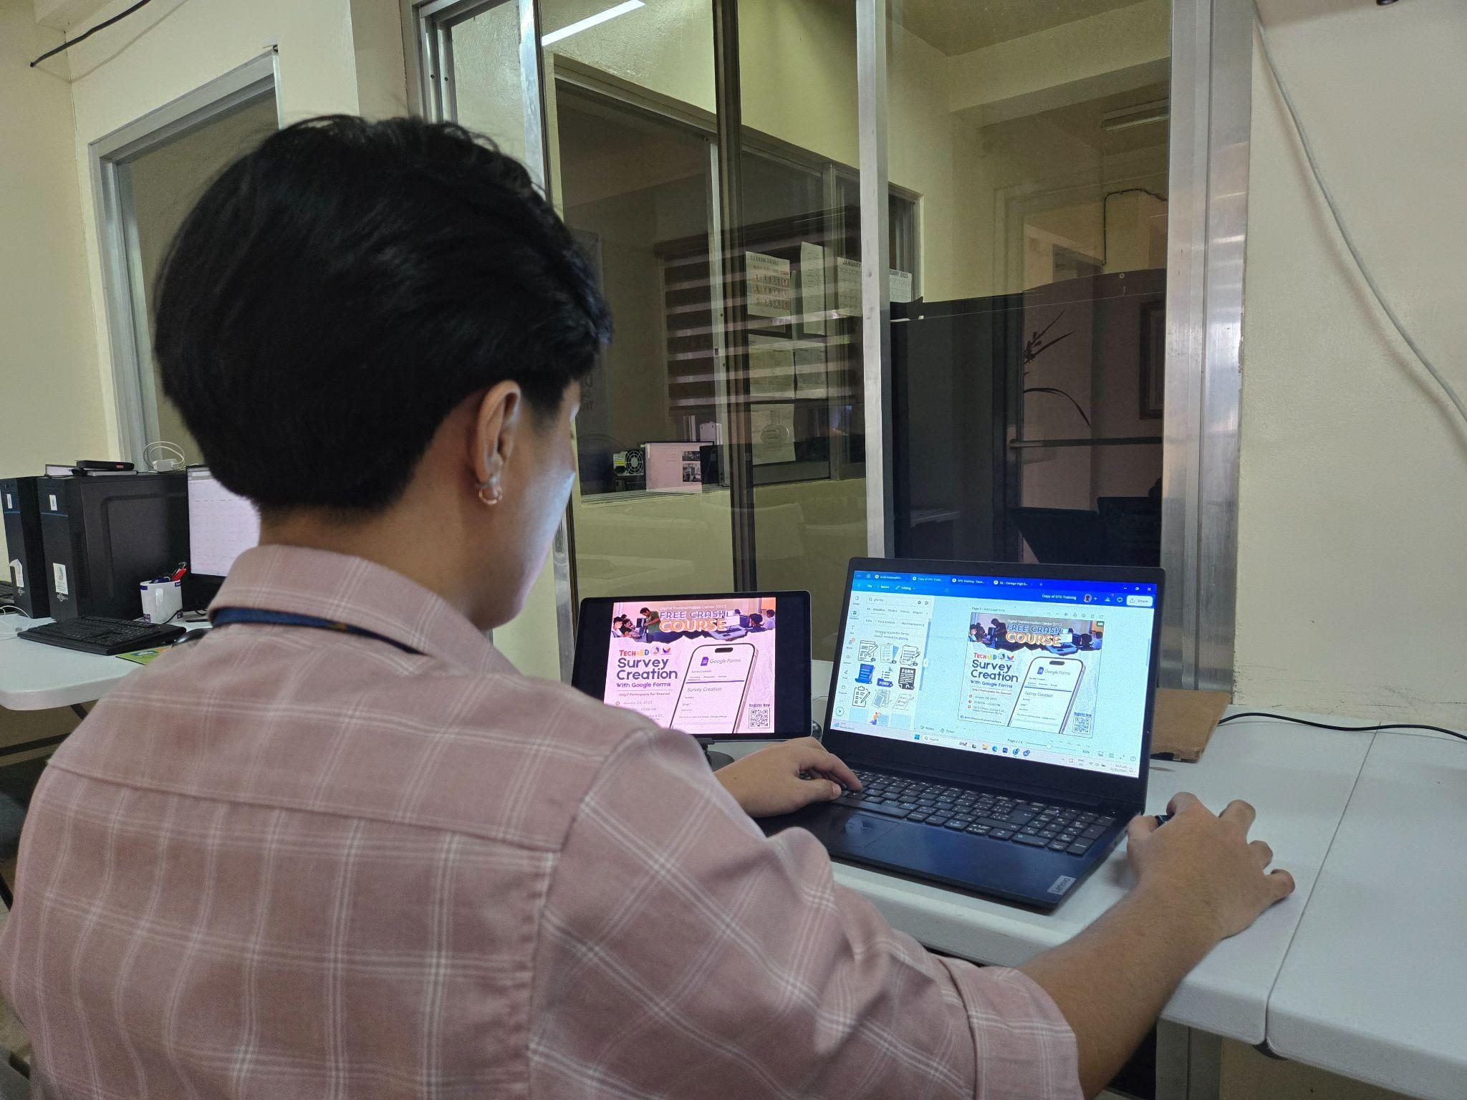

### Figure 42. Publication Material Designing Process

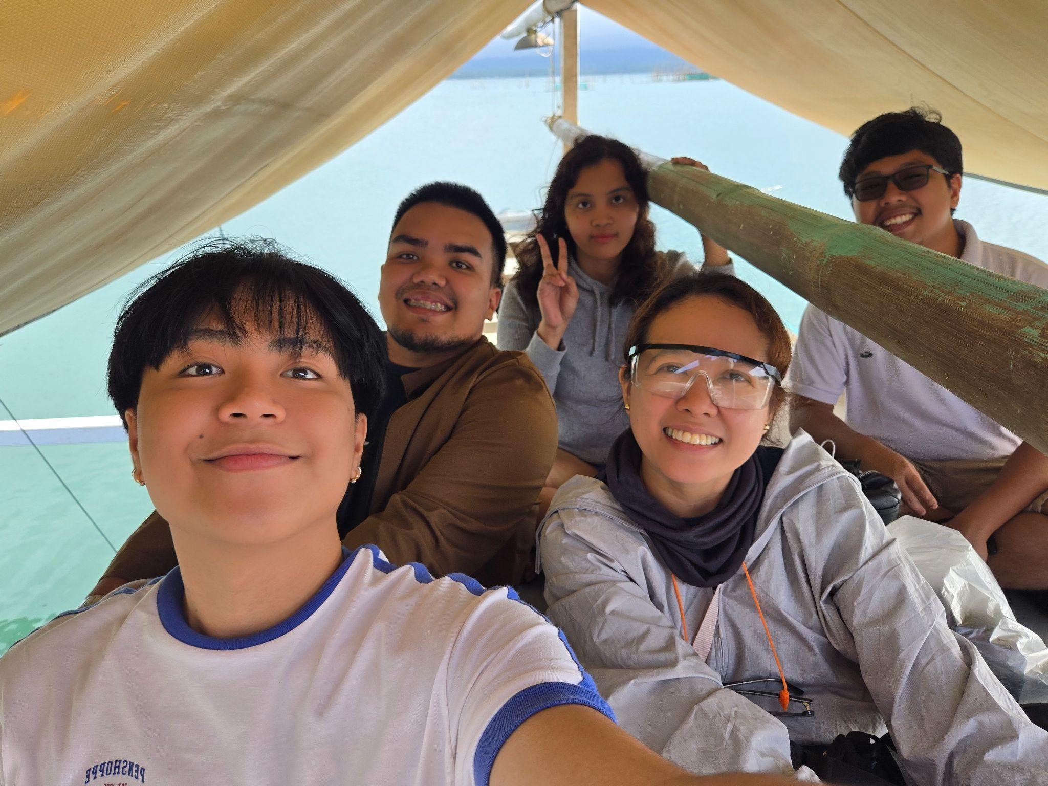

### Figure 43. Travel to Caringo Island - Office Photo Opt



### Figure 44. Digital Literacy Speaker in Caringo High School

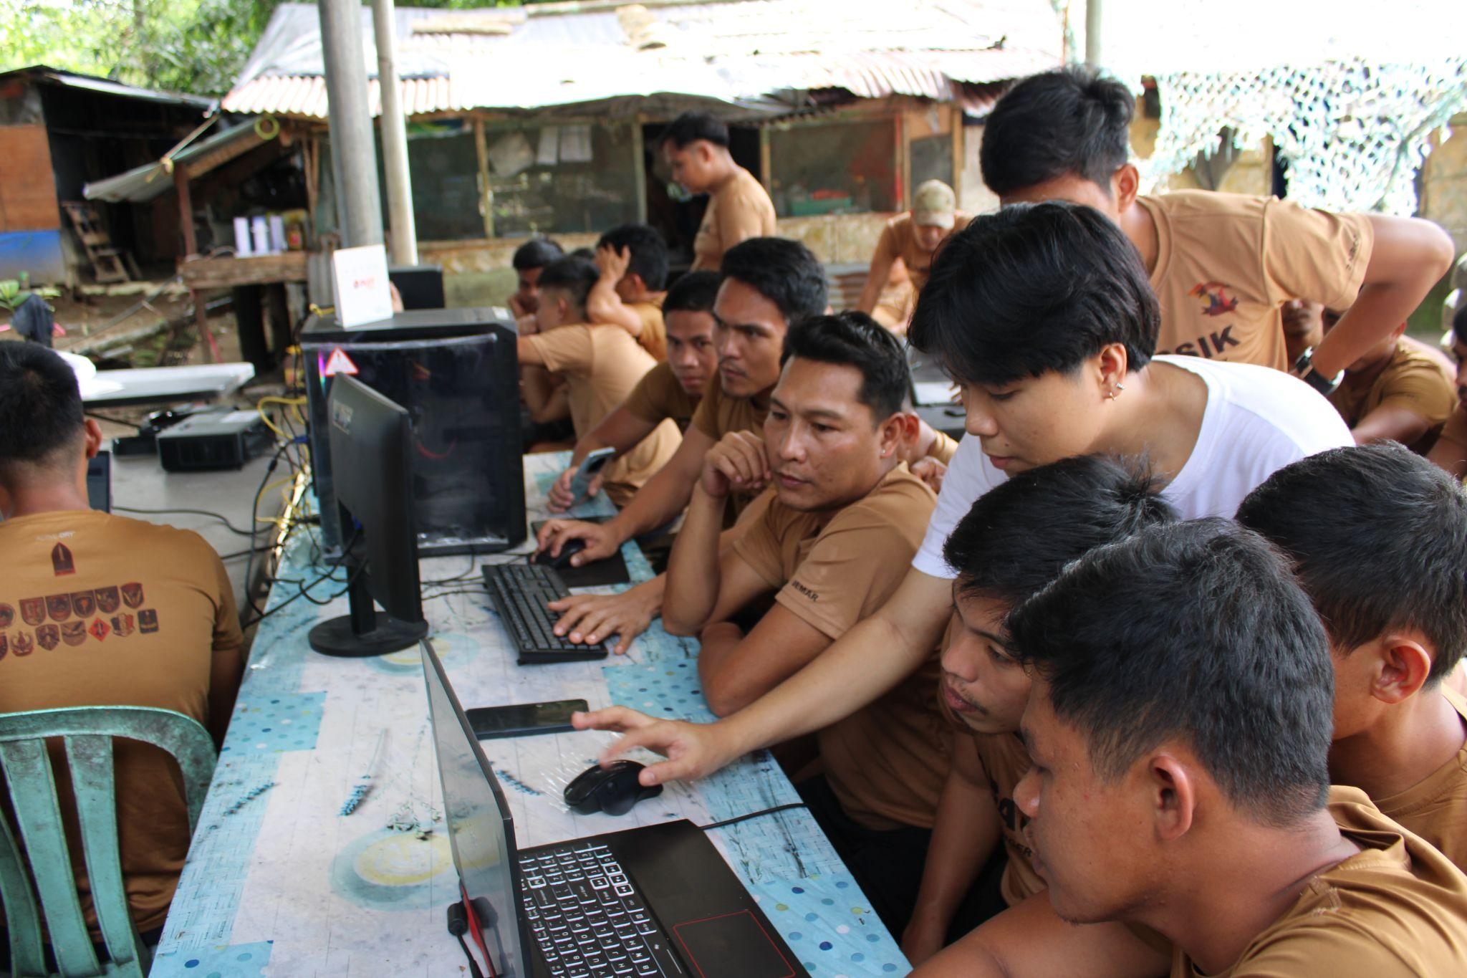

### Figure 45. Digital Literacy Facilitator on Camp Busig

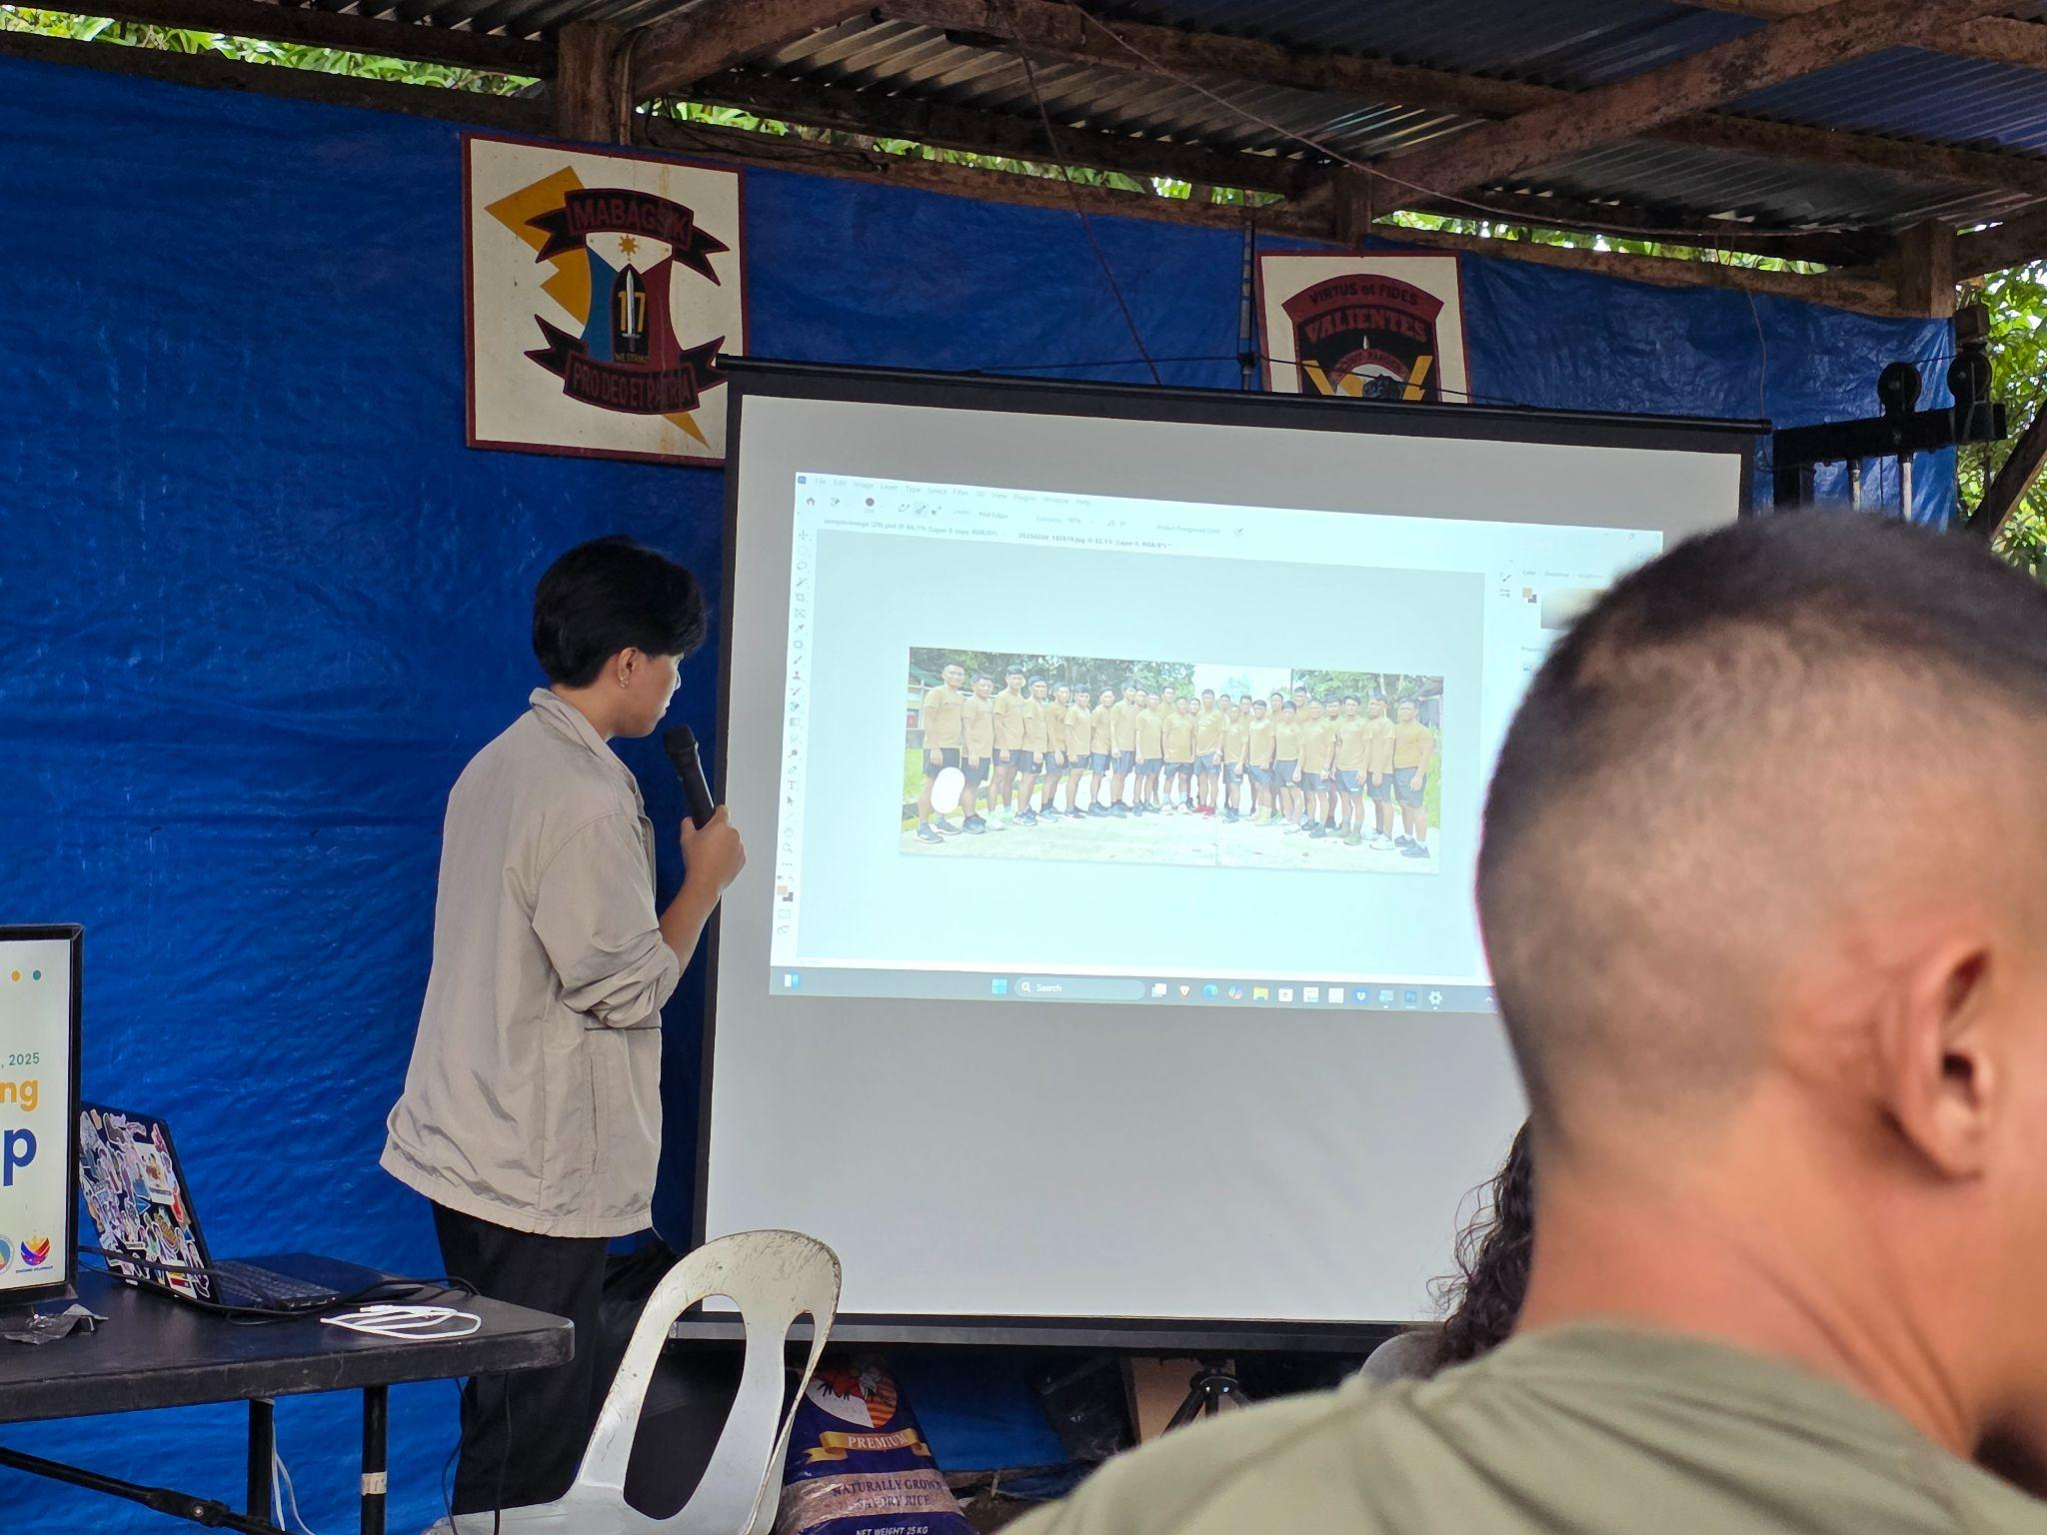

### Figure 46. Digital Literacy Speaker on Camp Busig

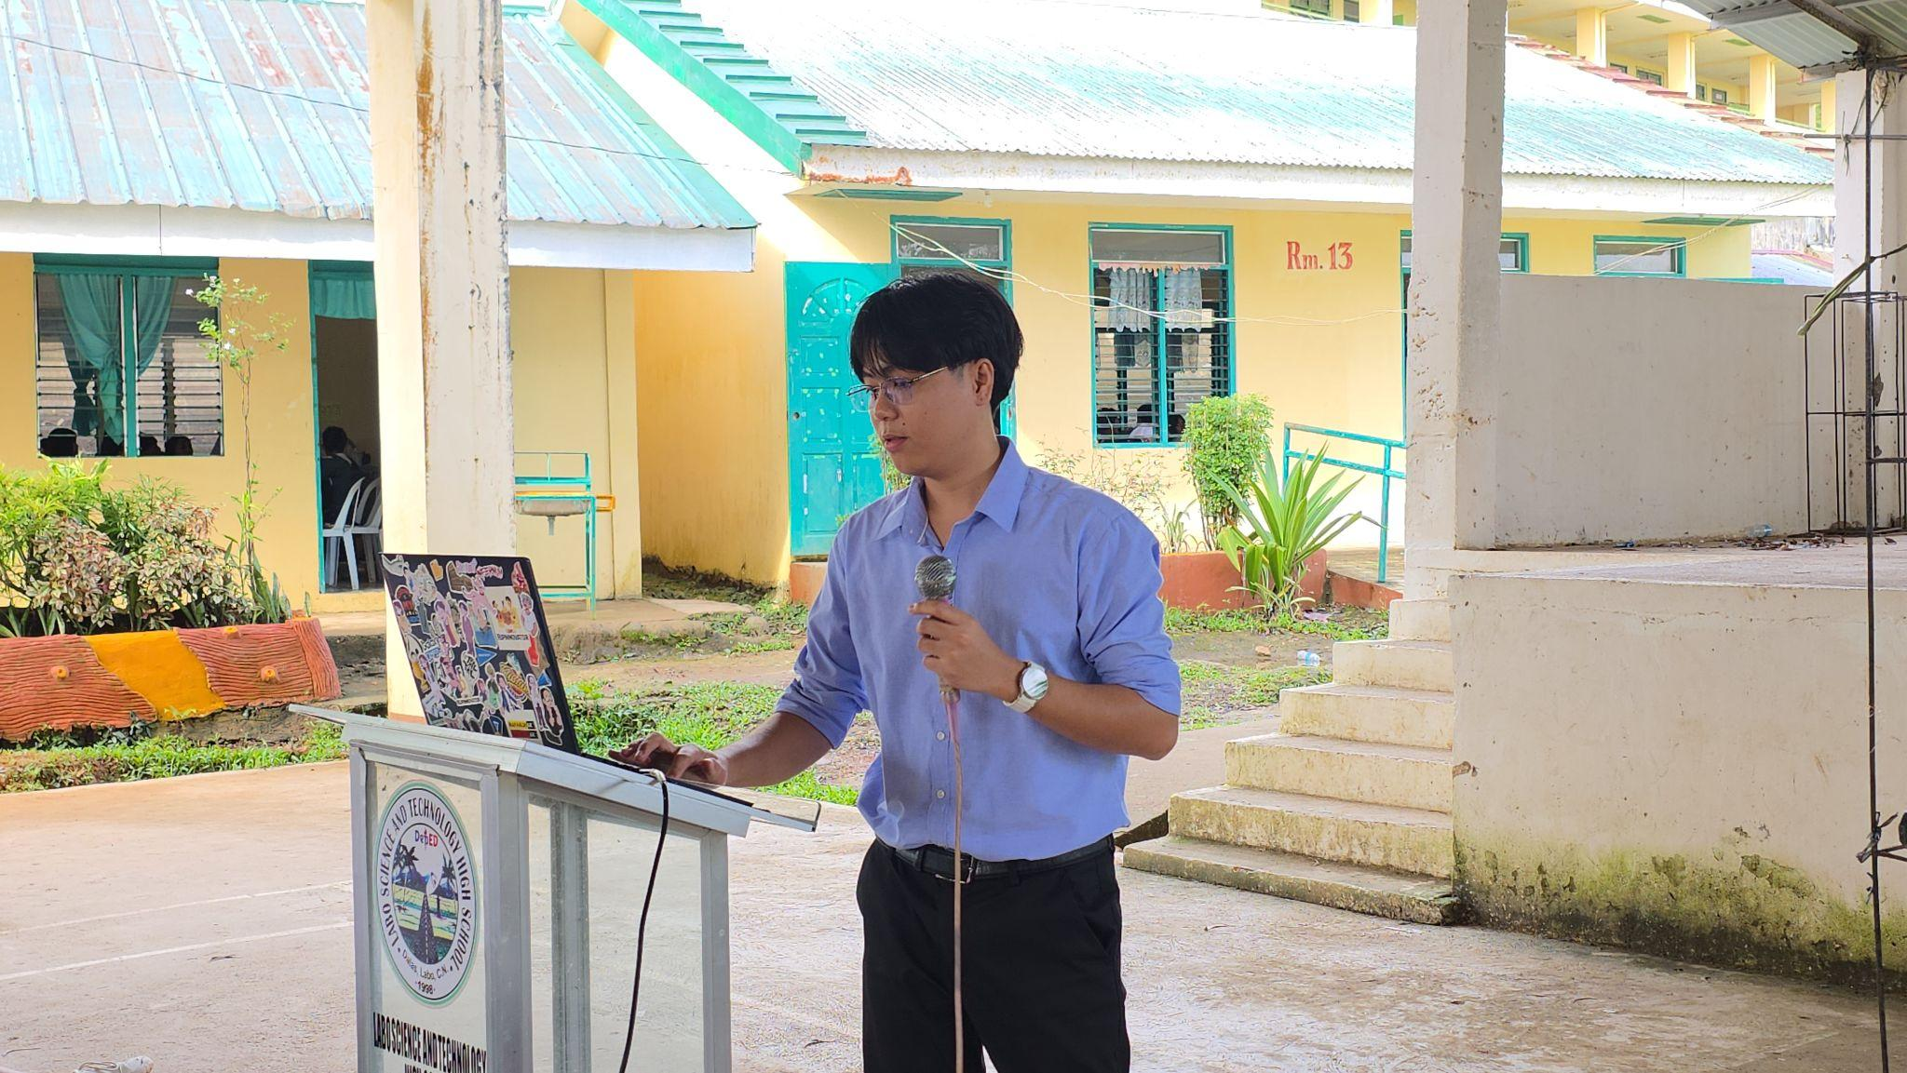

### Figure 47. Digital Literacy Speaker in LSTHS

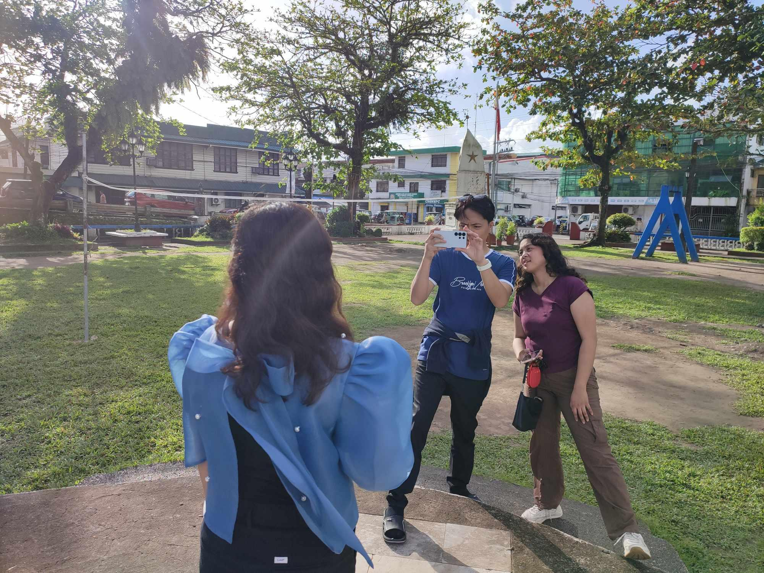

### Figure 48. Filming of DICT entry of National Anthem

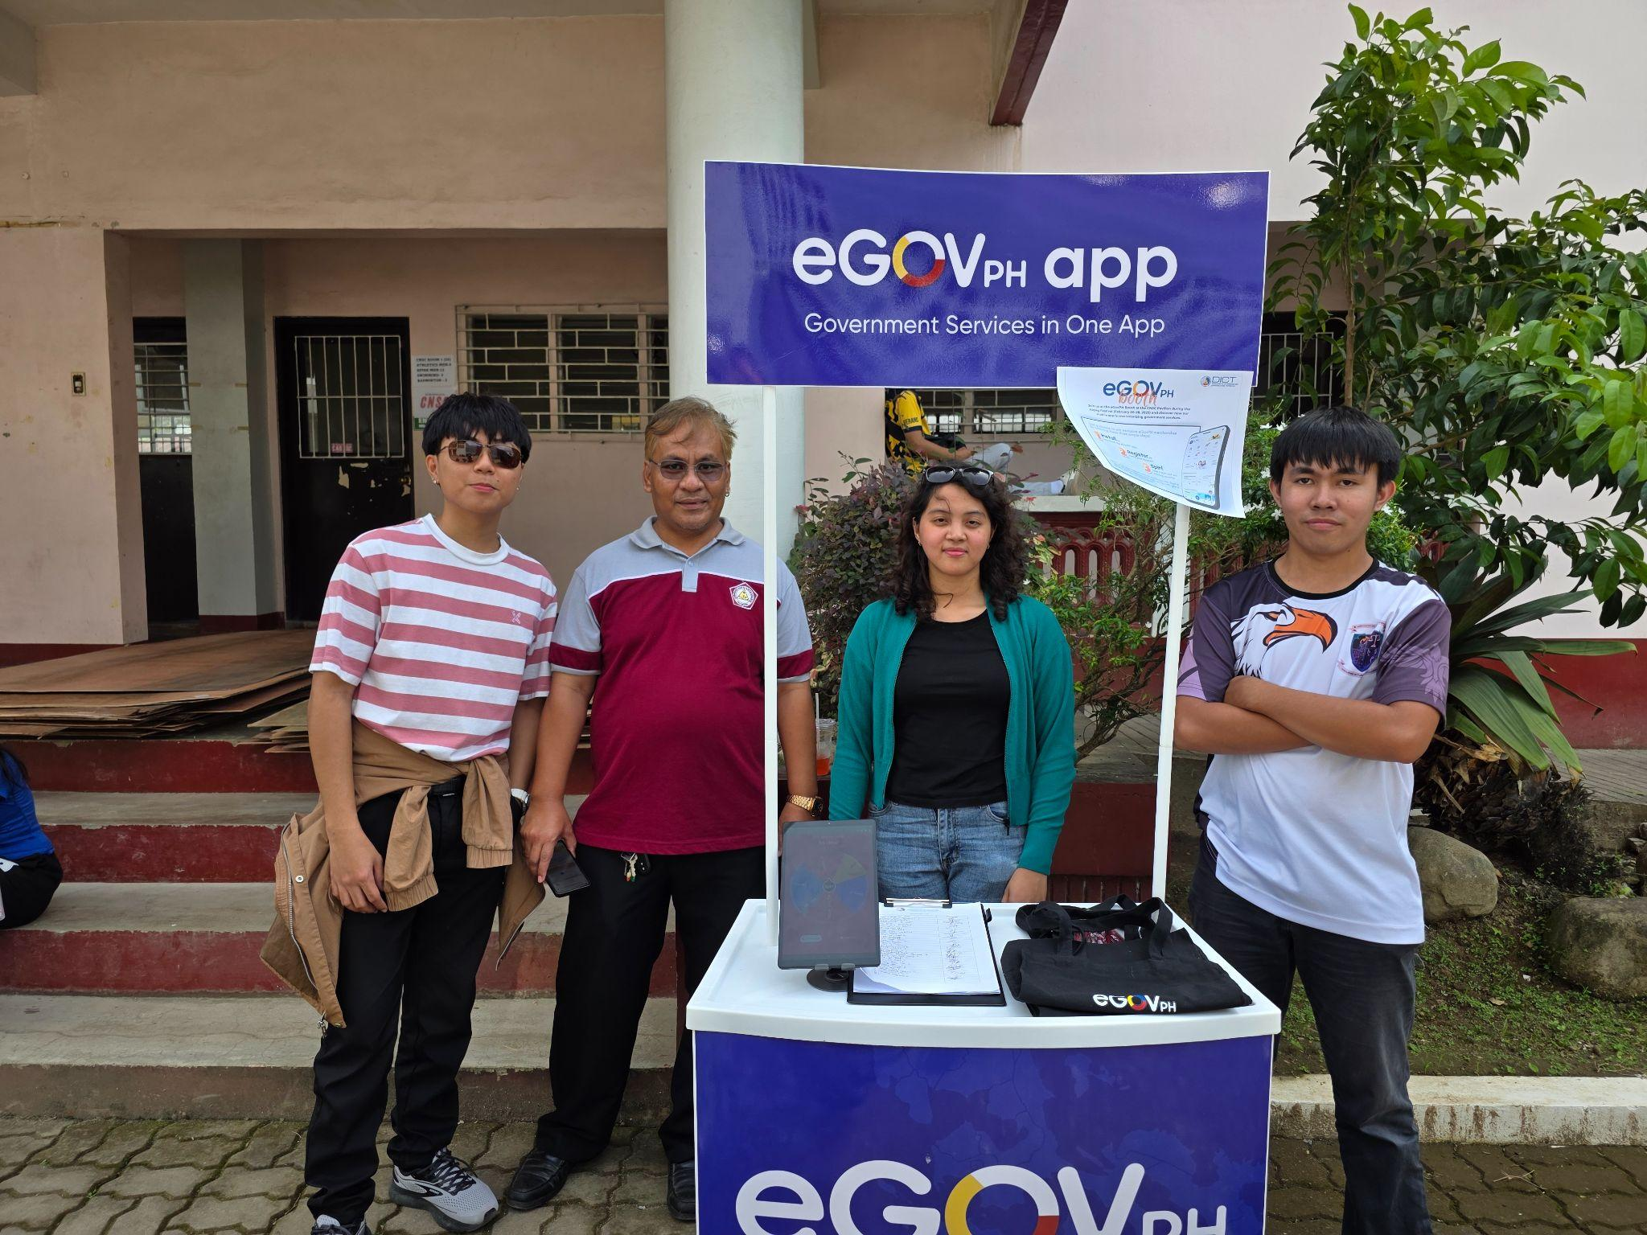

### Figure 49. eGovPH Booth Stand Facilitation in CNSC

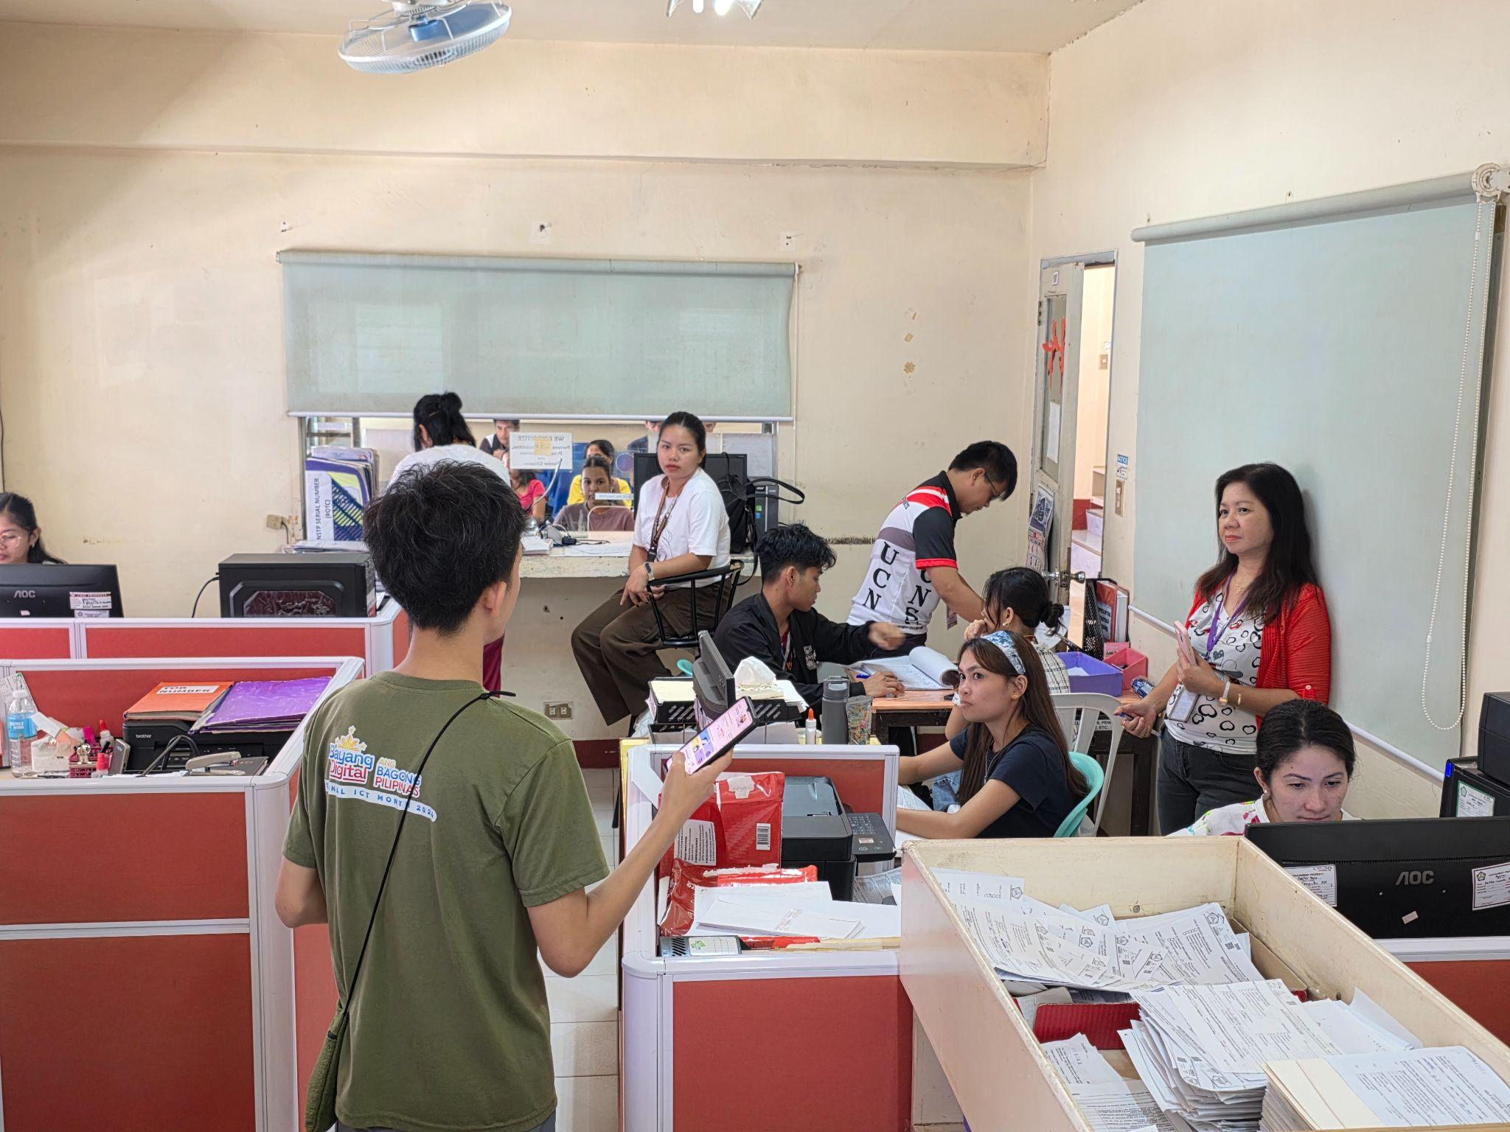

### Figure 50. Office-to-Office Campaign of eGovPH in CNSC

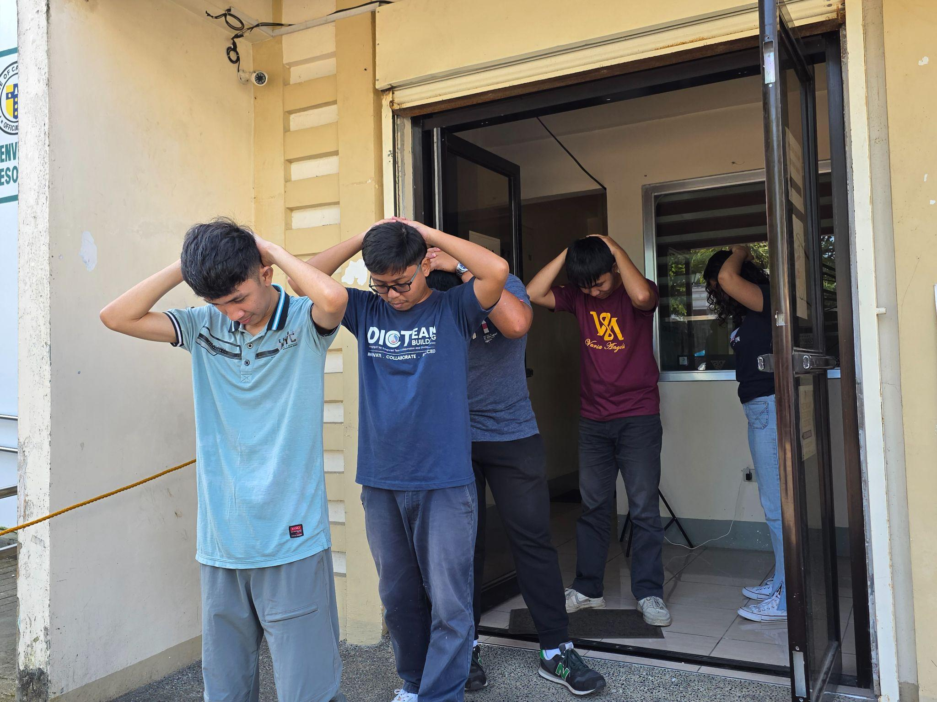

### Figure 51. DICT Earthquake Drill Practice

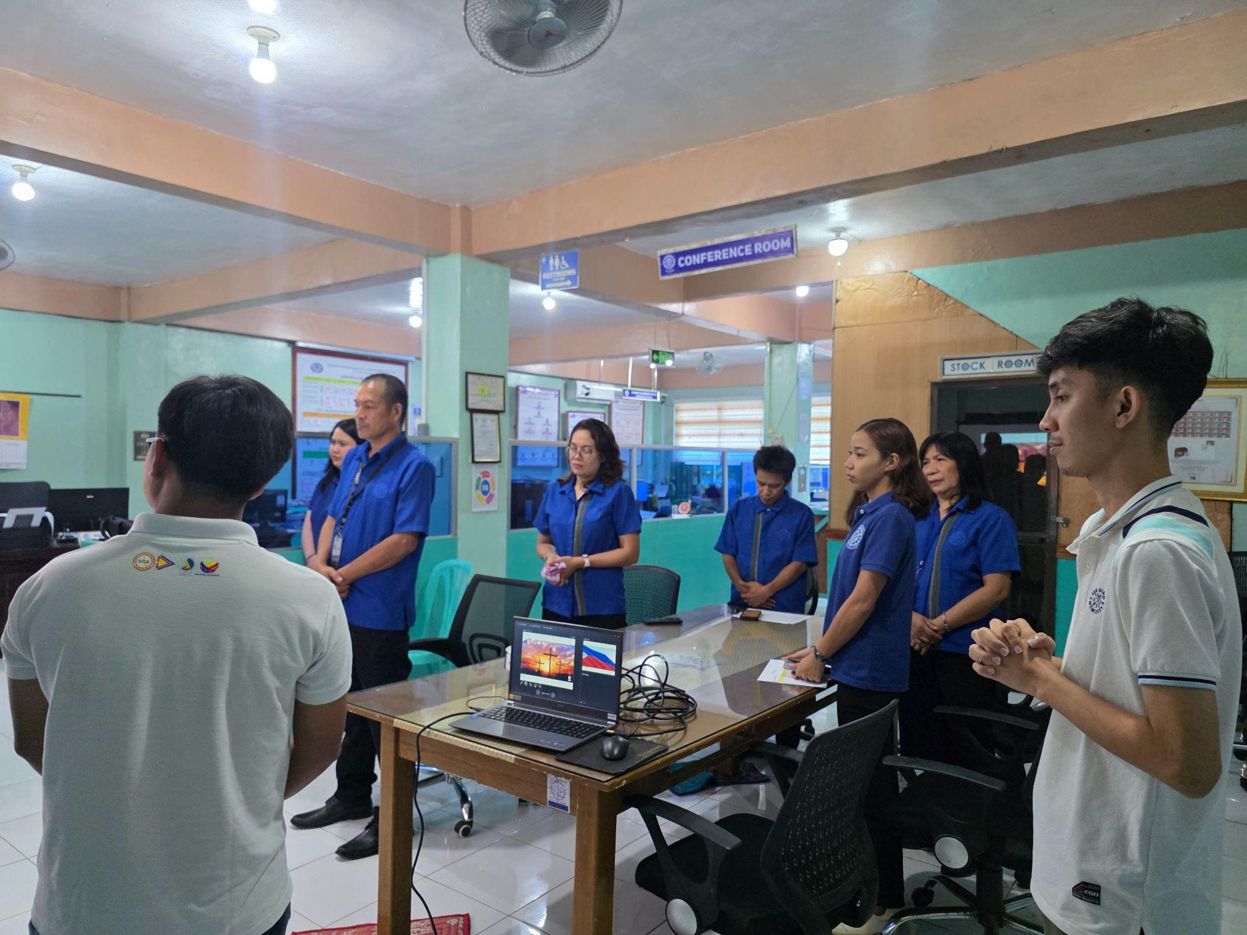

### Figure 52. Facilitation in TESDA Digital Literacy Training

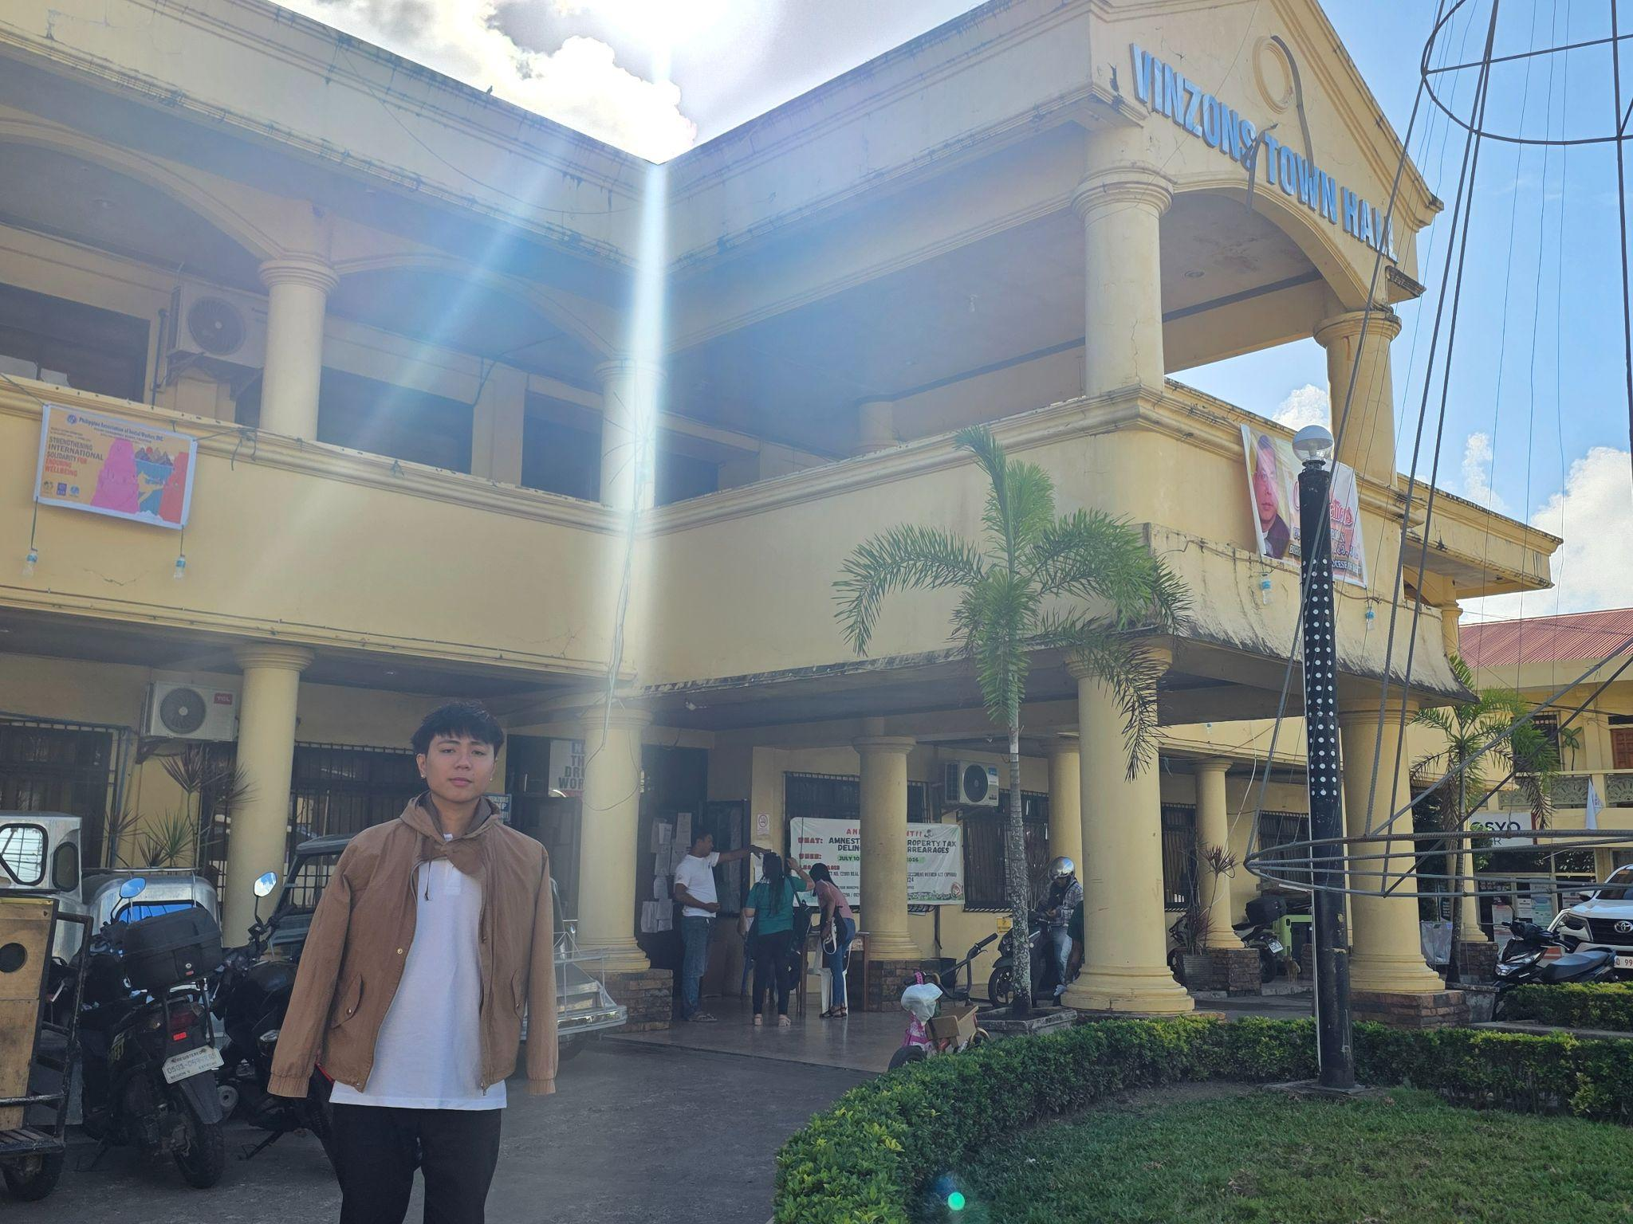

### Figure 53. Vinzons eGovernance Test Documentation

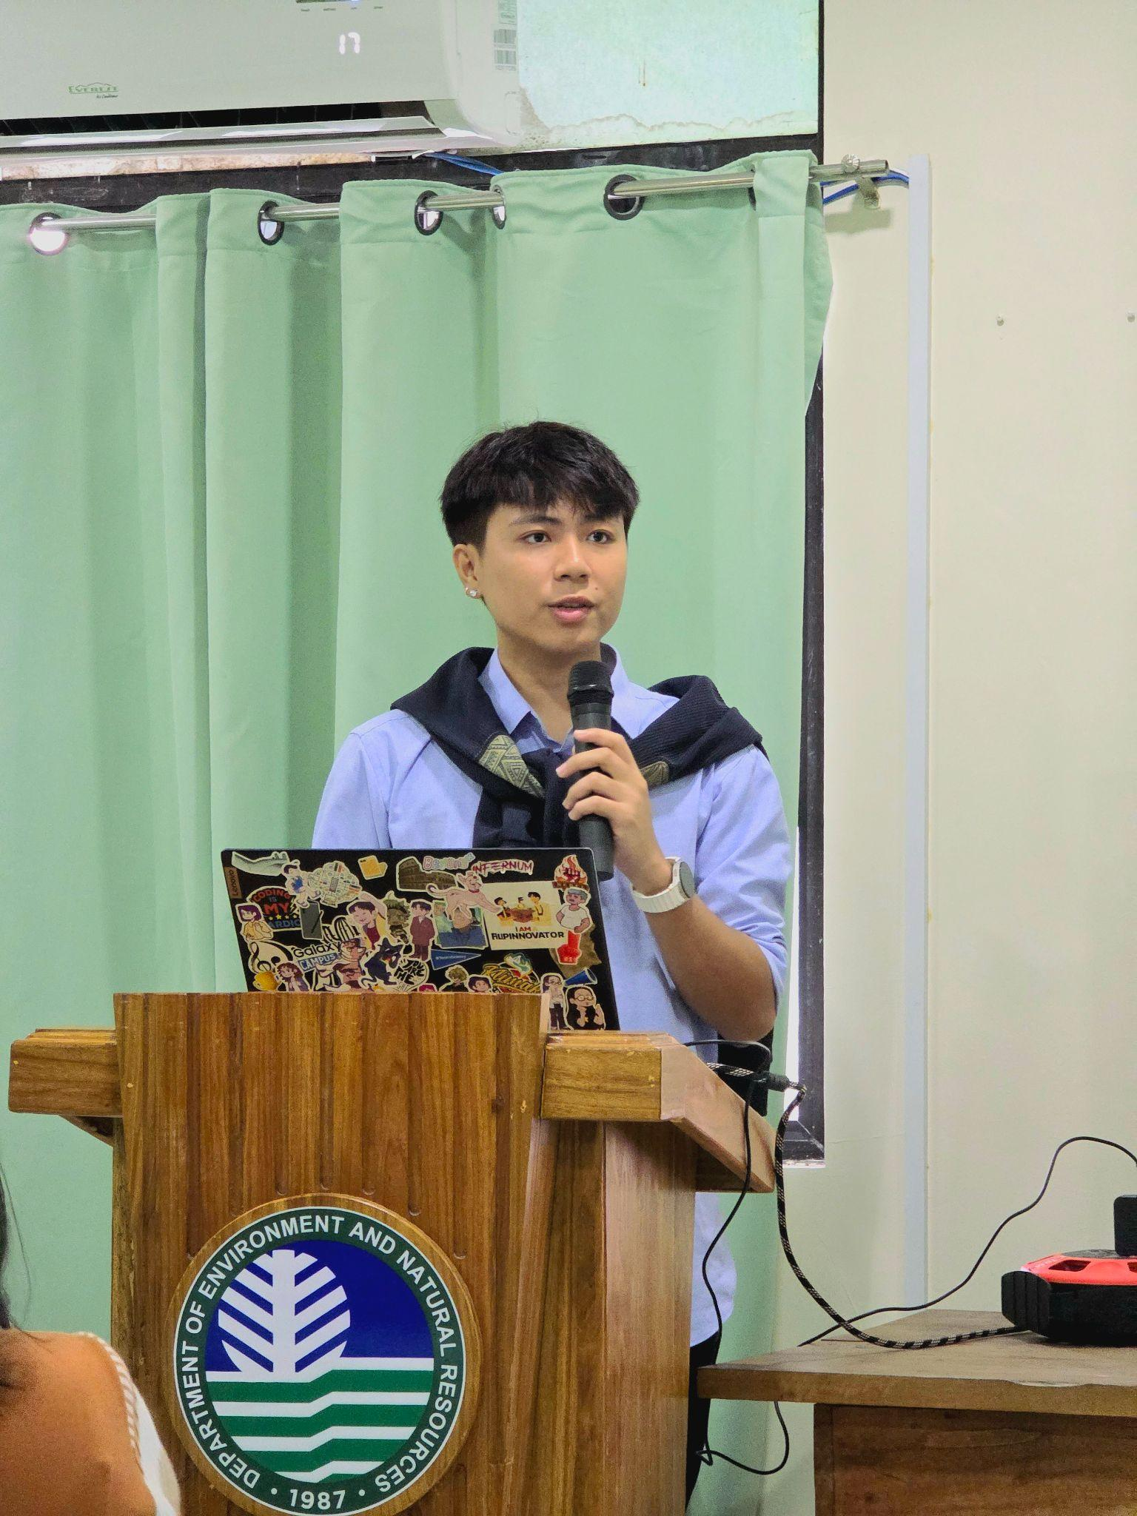

### Figure 54. Digital Literacy Training Speaker in PENRO

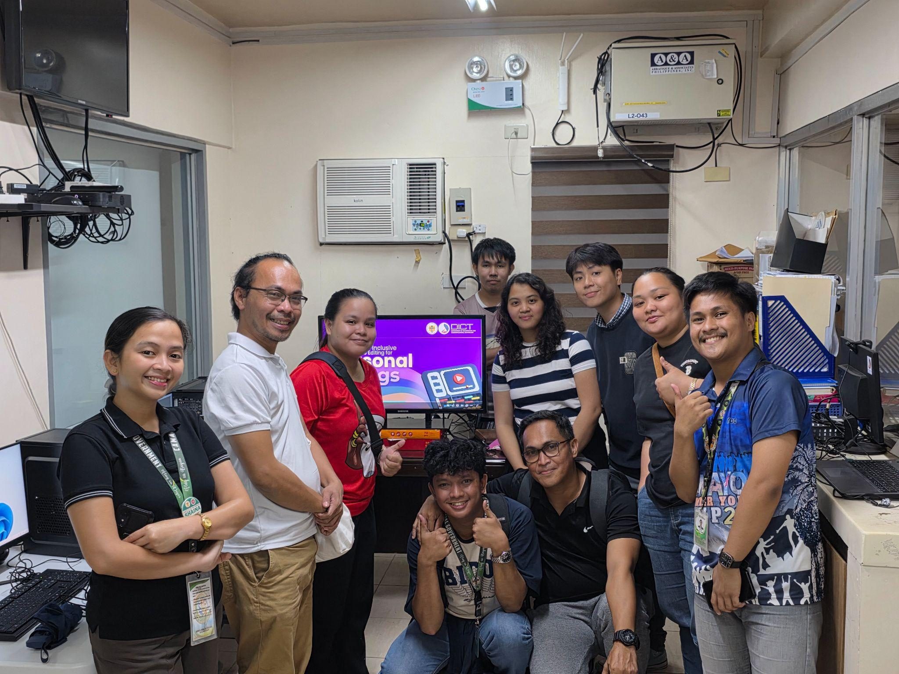

### Figure 55. In-Office Digital Literacy Speaker Photo Opt



### Figure 56. Facilitation in TESDA Digital Literacy Training

# CHAPTER III STUDENT REFLECTION AND ANALYSIS

## **Acquired Technical Competencies**

Lorem Ipsum

## **Professional Interactions and Interpersonal Experiences**

Lorem Ipsum

## **Significant Events**

Lorem Ipsum

## **Alignment Assessment of the BSIT Curriculum with Industry Demands**

Lorem Ipsum

## **Proposed Recommendations for the Improvement of the Practicum Program**

Lorem Ipsum

## **Advisory Remarks for Future Practicum and Internship Participants**

Lorem Ipsum

**REFERENCES:**

Department of Information and Communications Technology. (2025). *Department of Information and Communications Technology*. https://dict.gov.ph/home

*EGOVPH*. (n.d.). eGovPH. https://e.gov.ph/

*Department of Information and Communications Technology*. (n.d.). https://dict.gov.ph/pnpki

Free Wi-Fi for All. (2023, October 20). *Free Wi-Fi for all*. https://freepublicwifi.gov.ph/